|  |  |  |
| --- | --- | --- |
| Technical design  Project: Design of Heart Beats Measuring Device Project | | |
| **Enschede, 23 June 2015** | | |
| **Version 1.3** | | |
| **Made by :** | **Group:** Die Heart |  |
|  | Apitchaya Petchan | 336303 |
|  | Jan Plette | 324982 |
|  | Iris Mennings | 351341 |
|  | Ivar Koehorst | 336124 |
|  | Pepijn Assendorp | 357031 |
|  | Tom IJsselmuiden | 350333 |

Table of contents Technical Design document

1 Introduction 2

2 Summary from the functional 3

2.1 Analysis of requirements 3

2.2 Concept Principles 3

2.2.1Comparison of concept principles 4

3 Technical Design 6

3.1 Overview of Technical design 6

3.2 Elaboration of technical design 6

3.2.1 Mechanical 6

3.2.2 Electronic 8

3.2.3 Software 10

# 1 Introduction

As heart related diseases are increasing day by day, the need for an accurate and affordable heart rate measuring device or heart monitor is essential to ensure quality of health. However, most heart rate measuring tools and environments are expensive.

The project will carry out a design of a heart beats measuring device that can be remotely used and logged on a computer. The sensor itself has to be small enough that the user can carry and use the device without the need to make direct electrical connections to the body.

Goal of the Technical Design is to document how the functional design is adjusted to make a working product. In chapter 2 will show the conclusions from the functional design.

In chapter 3 elaboration of the technical design, this is done per discipline in mechanical, electronic and software.

# 2 Summary from the functional

## 2.1 Analysis of requirements

The project will carry out a design of a heart beats measuring device that can be remotely used and logged on a computer. The sensor itself has to be small enough that the user can carry and use the device without the need to make direct electrical connections to the body.

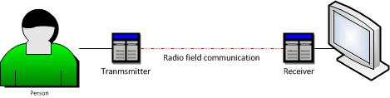

The target group are patients in the hospital and athletes in the gym. So the environment will always be inside a building. The device must be able to measure the heart signal and transmit wireless to a system that connects to a computer.

## 2.2 Concept Principles

In designing the heartbeat sensor, most of the user requirements have to be translated into technical requirements. From these requirements, the system can be designed properly, such that it complies with the user specifications.

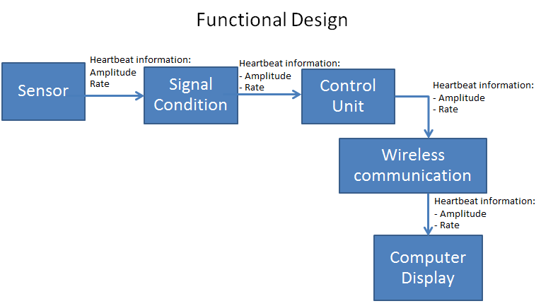

### 2.2.1Comparison of concept principles

Scores: 1 = poor. 2 = good. 3 = very good.

**Sensors and signal condition**

|  |  |  |  |  |  |  |
| --- | --- | --- | --- | --- | --- | --- |
|  | **Costs** | **Placement sensor** | **Accuracy** | **Safety** | **Distortion sensitive** | **Score** |
| **Movement** | 1 | 1 | 1 | 2 | 2 | 7 |
| **Optical** | 3 | 2 | 2 | 3 | 3 | 13 |
| **Sound** | 1 | 2 | 2 | 3 | 1 | 9 |

**Sensors and signal condition**

**Optical**, the heart creates pressure on the blood inside the veins. This pressure causes some movement on the veins, which is used before. But also the blood leaves other marks, the one we are talking about is color change. With a high blood density the finger gets red, which means there is a change in the optical spectrum. So, there is a possibility to get the heartbeat by light**.**

**Control unit**

|  |  |  |  |  |  |  |
| --- | --- | --- | --- | --- | --- | --- |
|  | **Knowledge required** | **Knowledge available** | **cost** | **Interface** | **Speed** | **Score** |
| **Micro controller (PIC)** | 2 | 3 | 3 | 3 | 3 | 14 |
| **FPGA** | 2 | 2 | 2 | 2 | 2 | 10 |

**Control unit**

**Microcontroller** becomes the most suitable control unit to use for the project. Because of the following reasons:

1. Microcontrollers are custom built mini computers in an IC while FPGAs are only composed of logic blocks that can be rewired electrically  
2. Microcontrollers consume less power than FPGAs  
3. FPGAs take a considerably longer time to set-up while there are ready built microcontrollers being sold for specific uses  
4. Building devices with FPGAs are more costly than microcontrollers.

**Wireless communication and computer display**

|  |  |  |  |  |  |  |
| --- | --- | --- | --- | --- | --- | --- |
| **Interface software** | **Knowledge required** | **Knowledge available** | **Reliability** | **Associability** | **Possibilities** | **Score** |
| **Visual Studio C#** | 2 | 3 | 3 | 3 | 3 | 14 |
| **Visual Studio Visual Basic** | 2 | 2 | 3 | 3 | 3 | 13 |
| **Java Ultraedit** | 2 | 1 | 1 | 1 | 1 | 6 |
| **Quartus, VHDL** | 2 | 2 | 2 | 2 | 1 | 9 |
| **Netbeans** | 2 | 2 | 2 | 2 | 1 | 9 |

**Wireless communication and computer display**

**Visual Studio C#** is the most suitable program to use for this project. C# is a very common language, so we can understand it all very well. Beyond, the software is easy to understand. Therefore anyone can handle it and it is easy to expand because there are very many possibilities.

**Mechanical parts**

|  |  |  |  |  |  |
| --- | --- | --- | --- | --- | --- |
| **Method** | **Cost** | **Accessibility** | **Wearable** | **Adjustably** | **Score** |
| **3d printing** | 3 | 3 | 3 | 3 | 12 |
| **Buying** | 1 | 1 | 3 | 1 | 6 |
| **Milling** | 2 | 2 | 2 | 2 | 8 |
| **Woodwork** | 2 | 2 | 2 | 2 | 8 |

**Mechanical part**

Overall the **3D printing** is the best option. It’s easy and cheap to make and there is a 3D-printer is available. We only need to make Solid Works drawings to be able to print it.

# 3 Technical Design

## 3.1 Overview of Technical design

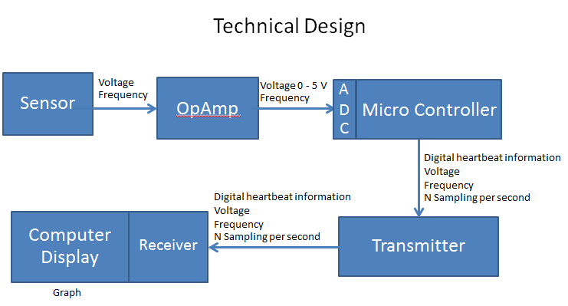

## 3.2 Elaboration of technical design

This is done per discipline: mechanical, electronic and software.

### 3.2.1 Mechanical

Because of the 3D-printing of the components there is no reason to make workdrawing. With the help of the 3D drawing wich is loaded in a program, who makes the printinstrucions and sends them to the printer. Below are the 3D designs that where just to print the parts.

**3.2.1.1 Fingerclamp**

The clamp is designed to fit around the user’s finger and with the build-in LEDs, the flow of blood in the finger is measured getting the hardbeat.

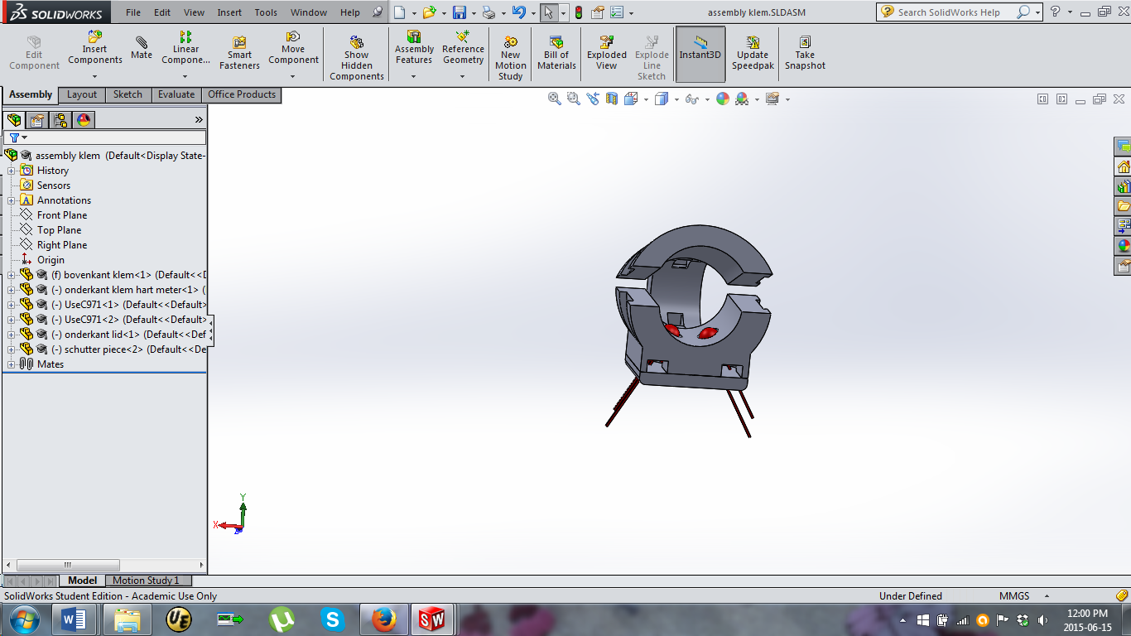 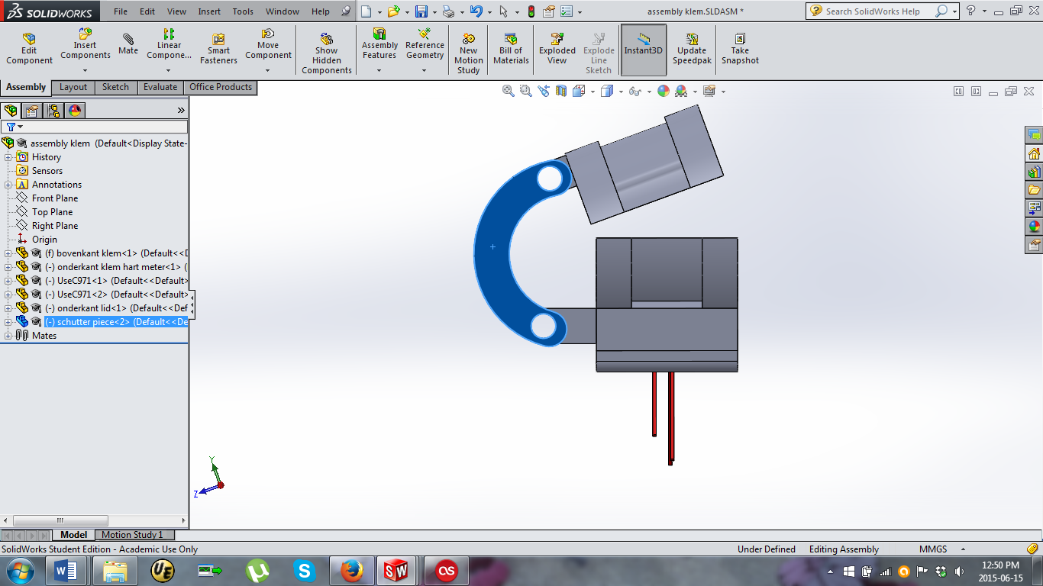

The clamp excist of 4 pieces which are held together with 2 M3 bolts, glue and velco. Because of the two points joint the clamp is able to fit on many fingers. The clamp is closed by wrapping the velco around it and sticking it to itself.

Only the LEDs are in the clamp so that it can stay small and light. The transmision is done in a box which is positiond on the forearm of the user.

**3.2.1.2 Armbox**

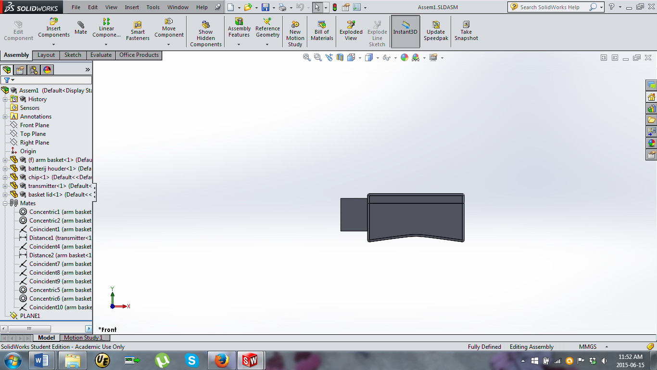 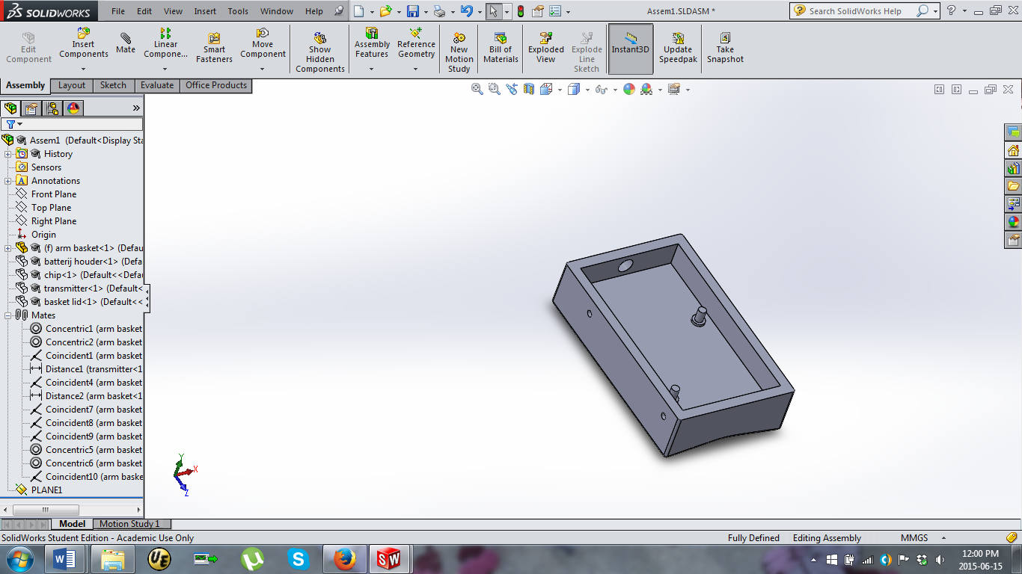

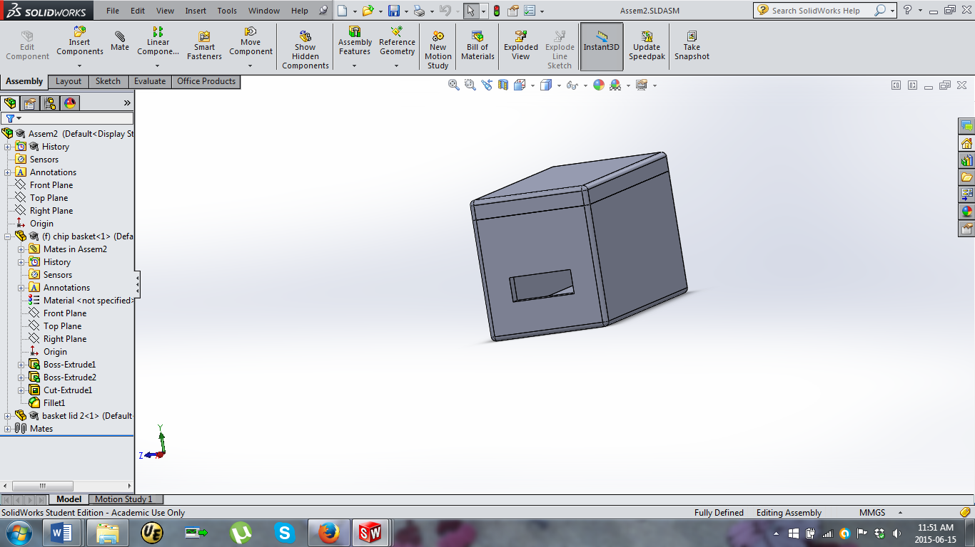

### 3.2.2 Electronic

#### **3.2.2.1Schematic**

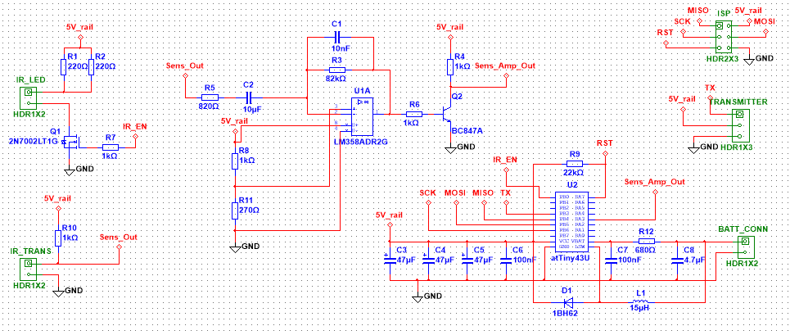

The schematic of the sensor

#### **3.2.2.2 PCB Design**

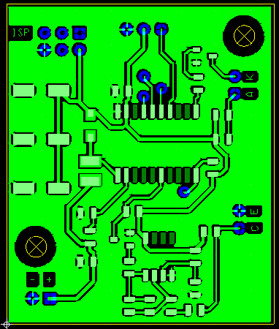

The top view

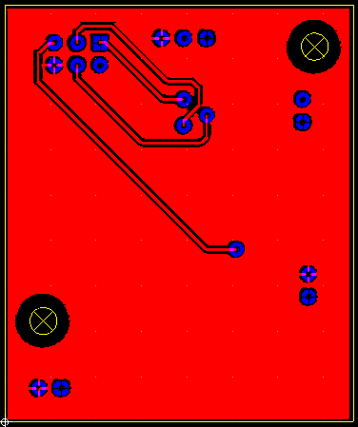

The bottom view

### 3.2.3 Software

